Date: 30.05.2025
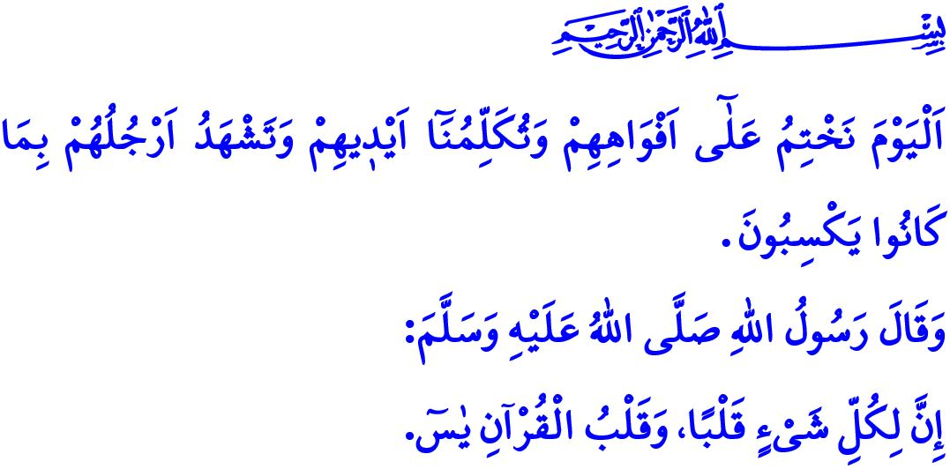
SURAH YA-SIN: THE HEART OF THE QUR’AN
Honorable Muslims!
One of the surahs in our Noble Book, the Holy Qur’an, is Surah Ya-Sin. Surah Ya-Sin is a surah that appeals to the human mind and conscience, reminds us that the universe was created in balance and harmony, gives meaning to life, revives hearts, and imparts truth and reality. Our beloved Prophet (saw) praises this surah by saying, “Everything has a heart, and the heart of the Qur’an is Surah Ya-Sin.” Our beloved nation, shaped by Anatolian wisdom, has made it a custom to recite Surah Ya-Sin at various occasions—from birth to death, from joy to sorrow, and from health to illness. However, the purpose of reciting this surah is not merely to utter its words, but also to reflect upon its meaning and to apply its messages in our lives.
Dear Believers!
Beginning with an oath to the Qur’an, which was sent as a guide for humankind, Surah Ya-Sin emphasizes that true peace in this world and the Hereafter can only be attained by adhering to its commands.
With the declaration, وَاَنِ اعْبُدُون۪يۜ هٰذَا صِرَاطٌ مُسْتَق۪يمٌ “Worship Me ˹alone˺? This is the Straight Path.”, it invites us to serve Allah alone and to lead a life guided by righteousness. This righteousness is the straight path of Islam—beginning with tawhid, strengthened through acts of worship, and perfected with good morals. A believer on this path should embody sincerity in all deeds and conduct. They should avoid display and ostentation.
With the verse, “You ˹O Prophet˺ are truly one of the messengers upon the Straight Path.”, Surah Ya-Sin informs us that the Messenger of Allah (saw) is a blessed messenger who calls all humanity to happiness in this world and the Hereafter. Our Prophet (saw) is the source of guidance who shows humanity what is right and wrong, good and bad, halal and haram. He is the Messenger of Mercy who taught us to love orphans, to maintain good relations with our neighbors, and to be forgiving and compassionate.
Esteemed Muslims!
Surah Ya-Sin answers the question of the disbelievers, “Who will give life to decayed bones?”, with the decree, قُلْ يُحْي۪يهَا الَّـذ۪ٓي اَنْشَاَهَٓا اَوَّلَ مَرَّةٍۜ “They will be revived by the One Who produced them the first time”.
Our beloved Prophet (saw) recommends reciting Surah Ya-Sin for the deceased believers. This advice teaches us that every soul will taste death, that we must prepare for the Hereafter before our time comes, and that we will be held accountable for our words and deeds. Surah Ya-Sin warns us of this reality: “On this Day We will seal their mouths, their hands will speak to Us, and their feet will testify to what they used to commit.” Muslims who possess this awareness should not distance themselves from goodness, worship, and virtuous conduct, which are the very purposes of creation. They should never incline towards evil deeds. They should not live as though there is no death, no Hereafter, no reckoning, and no accountability. They should fulfill their responsibilities towards their Lord, themselves, their family, society, and the environment. They should always stand with the oppressed and the wronged—especially our brothers and sisters in Gaza, who are courageously resisting Zionist oppressors and their collaborators in defence of their homeland and sanctities despite all adversities and the lack of resources. They must confront these murderers, who recognize no human or moral principles, both materially and spiritually.
Dear Believers!
Surah Ya-Sin gives glad tidings to the believers as follows: اِنَّ اَصْحَابَ الْجَنَّةِ الْيَوْمَ ف۪ي شُغُلٍ فَاكِهُونَۚ “Indeed, on that Day the residents of Paradise will be busy enjoying themselves.” سَلَامٌ قَوْلاً مِنْ رَبٍّ رَح۪يمٍ “And “Peace!” will be ˹their˺ greeting from the Merciful Lord.” It warns those sinners captivated by Satan as follows: هٰذِه۪ جَهَنَّمُ الَّت۪ي كُنْتُمْ تُوعَدُونَ “This is the Hell you were warned of.” اِصْلَوْهَا الْيَوْمَ بِمَا كُنْتُمْ تَكْفُرُونَ “Burn in it Today for your disbelief.”
Dear Muslims!
We are in the month of Dhu al-Hijjah. Let us regard these blessed days as a precious opportunity to increase our worship, reflect sincerely upon our shortcomings, and turn to our Lord in heartfelt repentance. Let us make it an occasion to hold ourselves to account before the Day of Reckoning comes.

I would like to conclude this Friday’s khutbah with the final verse of Surah Ya-Sin: فَسُبْحَانَ الَّذ۪ي بِيَدِه۪ مَلَكُوتُ كُلِّ شَيْءٍ وَاِلَيْهِ تُرْجَعُونَ “So glory be to the One in Whose Hands is the authority over all things, and to Whom ˹alone˺ you will ˹all˺ be returned.”

Tirmidhi, Fadail al-Qur'an, 7.
Ya-Sin, 36/61.
Ya-Sin, 36/3, 4.
Ya-Sin 36/78, 79.
Abu Dawud, Jana’iz, 19, 20.
Ya-Sin, 36/65.
Ya-Sin, 36/55.
Ya-Sin, 36/58.
Ya-Sin, 36/63, 64.
Ya-Sin, 36/83. General Directorate of Religious Services

